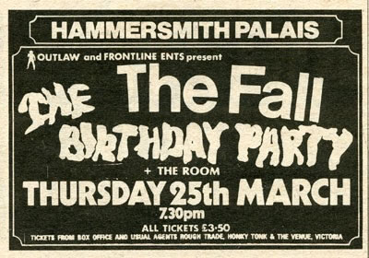

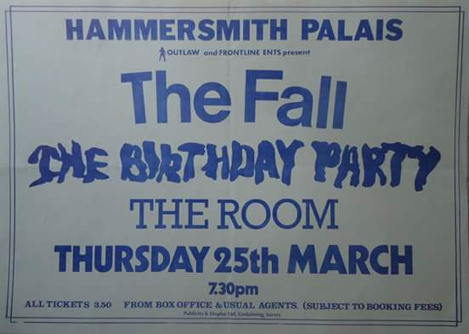

**The Fall London, Hammersmith Palais 3/28/82**

**The Fall London, Hammersmith Palais 3/28/82**

**The Fall London, Hammersmith Palais**

**Thursday, March 28 1982**

1. [D1] Hip Priest
2. I'm into C.B.
3. Mere Pseud Mag Ed
4. Just Step Sideways
5. Flat of Angles
6. Who Makes the Nazis
7. Wings
8. A Town Called Crappy
9. Solicitor in Studio
10. Look, Know
11. [D2] Lie Dream of a Casino Soul
12. Hexen Definitive >
13. And This Day
14. The Classical
15. Fantastic Life (A Derek Erdman Tape)

**The Fall London, Hammersmith Palais**

**Thursday, March 28 1982**

**The Fall London, Hammersmith Palais**

**Thursday, March 28 1982**

1. [D1] Hip Priest
2. I'm into C.B.
3. Mere Pseud Mag Ed
4. Just Step Sideways
5. Flat of Angles
6. Who Makes the Nazis
7. Wings
8. A Town Called Crappy
9. Solicitor in Studio
10. Look, Know
11. [D2] Lie Dream of a Casino Soul
12. Hexen Definitive >
13. And This Day
14. The Classical
15. Fantastic Life (A Derek Erdman Tape)

Between Wings and Solicitor, the short "Town Called Crappy" (aka "Don't Like Maggie"), which appears on Sanctuary's expanded "Room to Live" (2005). Thanks to Manchester District Music Archive for the ad.